23CSU5E24T: Professional Elective I: Data Analysis and Visualization
TYBTech. CSE
Report Writting

Activity_2
Activity Title: Technology-Enhanced Learning (TEL)

Problem Statement: Apply basic data wrangling, exploratory data analysis (EDA), summary statistics, and visualization using R-programming.

Theoretical Concept:
Technology-Enhanced Learning (TEL) combines the power of analytical tools and digital technologies to support data-driven learning.
Using R and RStudio, learners can interact with raw data, clean and process it, visualize trends, and interpret insights.
This hands-on approach helps understand how technology supports real-world business decision-making.
In this activity, R was used to analyze an online retail dataset, helping identify sales patterns, best-selling products, and high-traffic hours — turning raw data into actionable insights.

Dataset description:

The dataset used is the Online Retail dataset from the UCI Machine Learning Repository
📎 https://archive.ics.uci.edu/ml/machine-learning-databases/00352/Online%20Retail.xlsx

It includes transactions from December 2010 to December 2011 for a UK-based online store.
Each record represents a product purchased, including attributes such as:
- InvoiceNo: Unique transaction ID
- StockCode: Product code
- Description: Product name
- Quantity: Units sold
- InvoiceDate: Date and time of purchase
- UnitPrice: Price per item
- CustomerID: Customer identifier
- Country: Country of the customer

This dataset is widely used for transactional data analysis and sales forecasting exercises

Implementation Concept:

The analysis was done using R programming with libraries like tidyverse, lubridate, readxl, and ggplot2.
Steps followed:
- Load Data: Imported the .xlsx file using read_excel().
- Clean Data: Removed duplicates, missing CustomerIDs, and negative/zero quantities.

- Feature Engineering:
  - Created a Revenue column (Quantity * UnitPrice).
  - Extracted YearMonth, Hour, and Weekday from InvoiceDate.
- Compute Metrics:
  - Total monthly revenue
  - Average sales per transaction
  - Top 10 products by total revenue
- Visualizations:
  - Line chart of monthly revenue
  - Bar chart of top products
  - Heatmap of weekday vs hour sales

Program Execution:
Input:
The input is the "Online Retail" dataset in .xlsx format. R Code :

# --- Load Libraries ---
library(tidyverse)
library(lubridate)
library(readxl)
library(scales)

# --- Load Dataset ---
retail <- read_excel("C:/Users/lenovo/Downloads/Online Retail.xlsx")

# --- Clean Data ---
retail_clean <- retail %>%
filter(!is.na(CustomerID)) %>% # Remove missing Customer IDs
distinct() %>% # Remove duplicates
filter(Quantity > 0) %>% # Remove cancellations
mutate(InvoiceDate = as.POSIXct(InvoiceDate, format="%Y-%m-%d %H:%M:%S"))

# --- Feature Engineering ---
retail_clean <- retail_clean %>%
mutate(
Revenue = Quantity * UnitPrice, # Total sale per line
YearMonth = floor_date(InvoiceDate, "month"),
Hour = hour(InvoiceDate),
Weekday = wday(InvoiceDate, label = TRUE)
)

# --- Summary Metrics ---
monthly_sales <- retail_clean %>%
group_by(YearMonth) %>%
summarise(TotalRevenue = sum(Revenue))

avg_sales <- retail_clean %>%
summarise(AverageSalePerTxn = mean(Revenue))

top_products <- retail_clean %>%
group_by(Description) %>%
summarise(TotalRevenue = sum(Revenue)) %>%
arrange(desc(TotalRevenue)) %>%
slice_head(n = 10)
# Time Series: Monthly Revenue
ggplot(monthly_sales, aes(x = YearMonth, y = TotalRevenue)) +
geom_line(color = "steelblue", size = 1) +
geom_point(color = "steelblue") +
scale_y_continuous(labels = comma) +
labs(title = "Monthly Sales Revenue",
x = "Month",
y = "Total Revenue") +
theme_minimal()

# Bar Chart: Top 10 Products
ggplot(top_products, aes(x = reorder(Description, TotalRevenue), y = TotalRevenue)) +
geom_bar(stat = "identity", fill = "skyblue") +
coord_flip() +
scale_y_continuous(labels = comma) +
labs(title = "Top 10 Products by Revenue",
x = "Product",
y = "Total Revenue") +
theme_minimal()

# Heatmap: Weekday vs Hour
heatmap_data <- retail_clean %>%
group_by(Weekday, Hour) %>%
summarise(TotalSales = sum(Revenue))

ggplot(heatmap_data, aes(x = Hour, y = Weekday, fill = TotalSales)) +
geom_tile() +
scale_fill_gradient(low = "white", high = "red", labels = comma) +
labs(title = "Heatmap of Sales by Weekday and Hour",
x = "Hour of Day",
y = "Day of Week") +
theme_minimal()

# --- Insights (Print in Console) ---
cat("Average sale per transaction:", avg_sales$AverageSalePerTxn, "\n")
cat("Top 3 products:\n")
print(head(top_products, 3))

library(tidyverse)
library(lubridate)
library(readxl)
library(scales)
library(patchwork) # To combine plots

# Load and clean data
retail <- read_excel("C:/Users/lenovo/Downloads/Online Retail.xlsx") %>%
filter(!is.na(CustomerID), Quantity > 0) %>%
distinct() %>%
mutate(
InvoiceDate = as.POSIXct(InvoiceDate, format="%Y-%m-%d %H:%M:%S"),
Revenue = Quantity * UnitPrice,
YearMonth = floor_date(InvoiceDate, "month"),
Hour = hour(InvoiceDate),
Weekday = wday(InvoiceDate, label = TRUE)
)

# --- Monthly Revenue ---
monthly_sales <- retail %>%
group_by(YearMonth) %>%
summarise(TotalRevenue = sum(Revenue))

p1 <- ggplot(monthly_sales, aes(x = YearMonth, y = TotalRevenue)) +
geom_line(color = "steelblue", size = 1) +
geom_point(color = "steelblue") +
labs(title = "📈 Monthly Sales Revenue", x = "Month", y = "Total Revenue") +
theme_minimal()

# --- Top 10 Products ---
top_products <- retail %>%
group_by(Description) %>%
summarise(TotalRevenue = sum(Revenue)) %>%
arrange(desc(TotalRevenue)) %>%
slice_head(n = 10)

p2 <- ggplot(top_products, aes(x = reorder(Description, TotalRevenue), y = TotalRevenue)) +
geom_bar(stat = "identity", fill = "orange") +
coord_flip() +
labs(title = "Top 10 Products by Revenue", x = "Product", y = "Total Revenue") +
theme_minimal()

# --- Weekday vs Hour Heatmap ---
heatmap_data <- retail %>%
group_by(Weekday, Hour) %>%
summarise(TotalSales = sum(Revenue))

p3 <- ggplot(heatmap_data, aes(x = Hour, y = Weekday, fill = TotalSales)) +
geom_tile() +
scale_fill_gradient(low = "white", high = "red", labels = comma) +
labs(title = "Sales Heatmap (Weekday vs Hour)", x = "Hour of Day", y = "Day of Week") +
theme_minimal()

# --- Combine All (Dashboard Layout) ---
dashboard <- (p1 / (p2 | p3)) +
plot_annotation(title = "🛒 Online Retail Dashboard",
subtitle = "Summary of Sales Trends, Top Products, and Purchase Patterns",
theme = theme(plot.title = element_text(size = 16, face = "bold")))

# --- Save as Image ---
ggsave("C:/Users/lenovo/Downloads/retail_dashboard.jpg", dashboard, width = 14, height = 9, dpi = 3

Output:
The outputs are summary tables and visualizations that provide insights into the retail data.

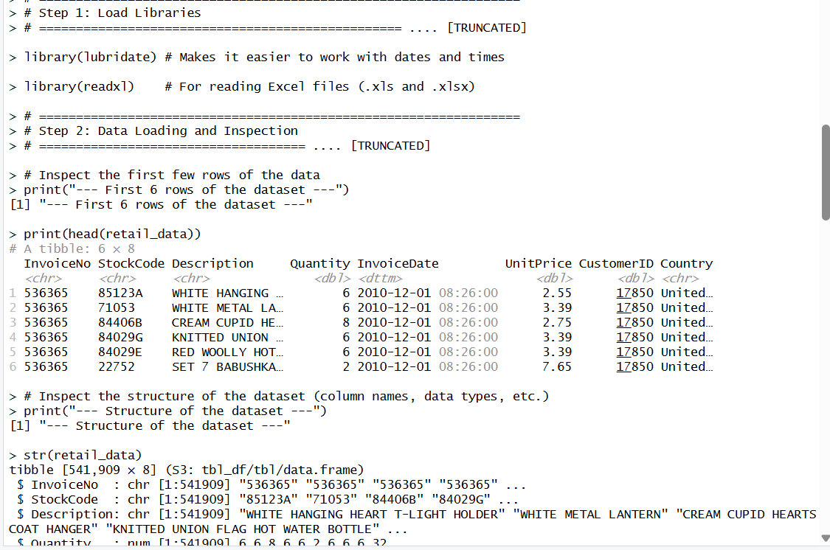

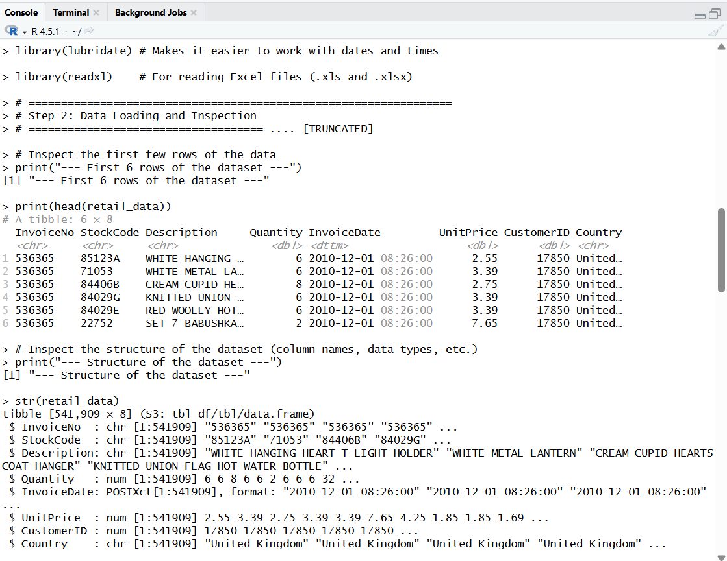

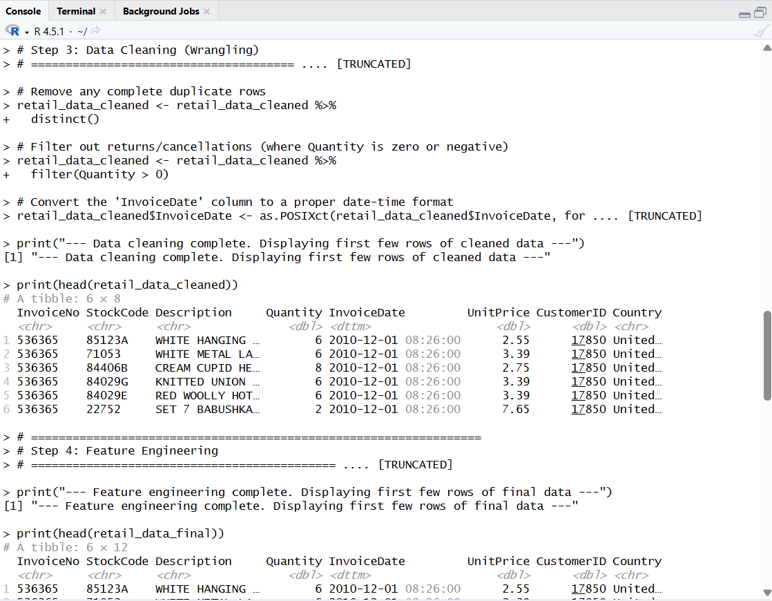

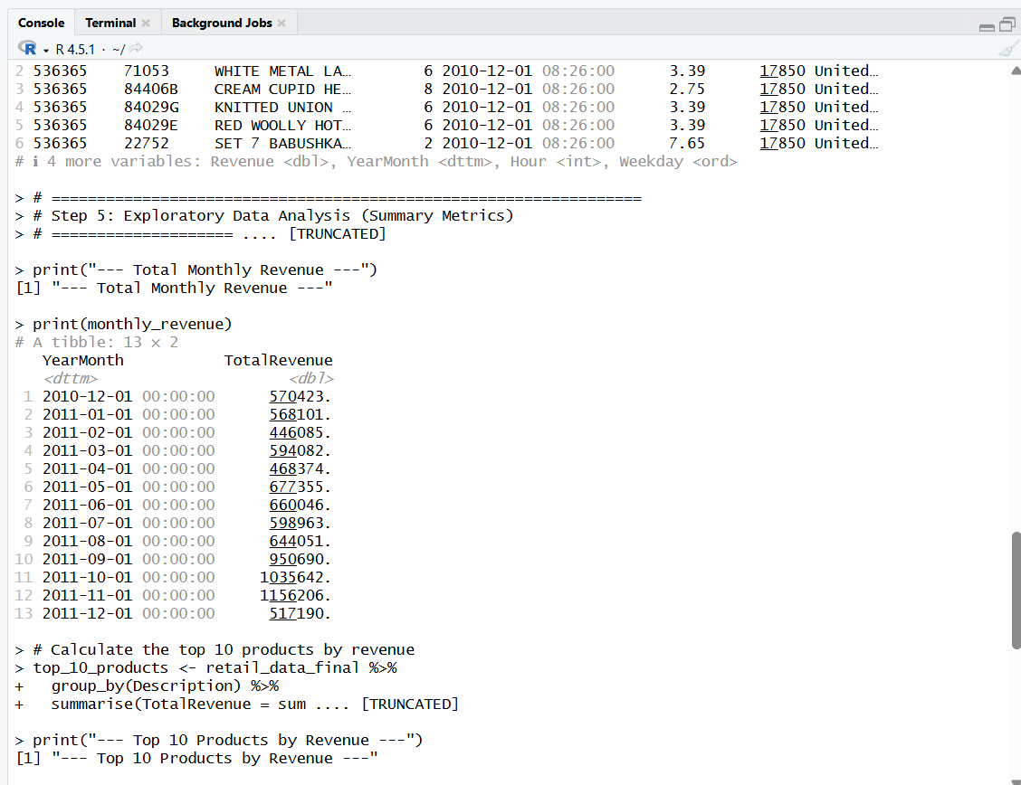

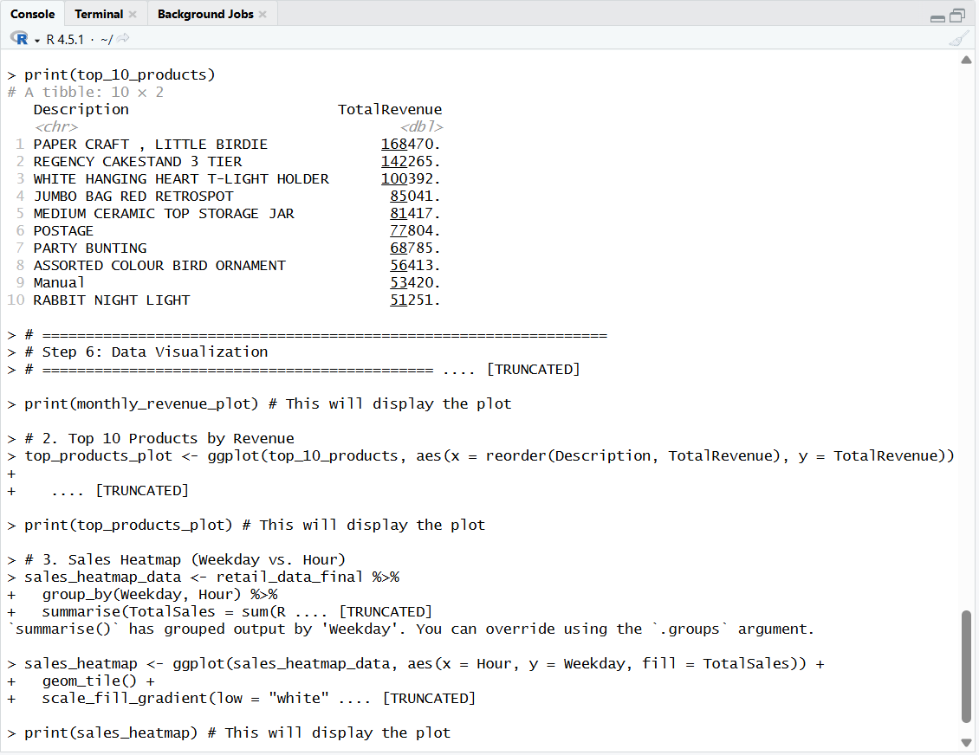

- Time Series of Monthly Revenue: This plot shows a strong upward trend in sales towards the end of the year, likely due to holiday shopping.

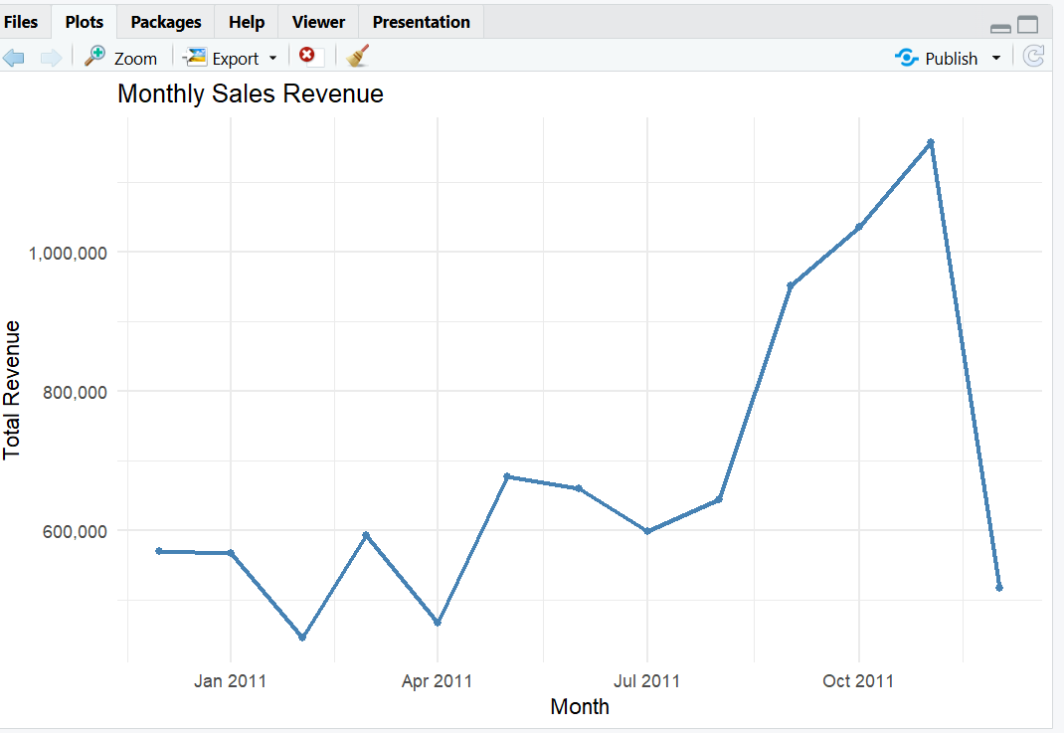

- Top 10 Products by Revenue: This chart identifies the products that contribute the most to the company's revenue.

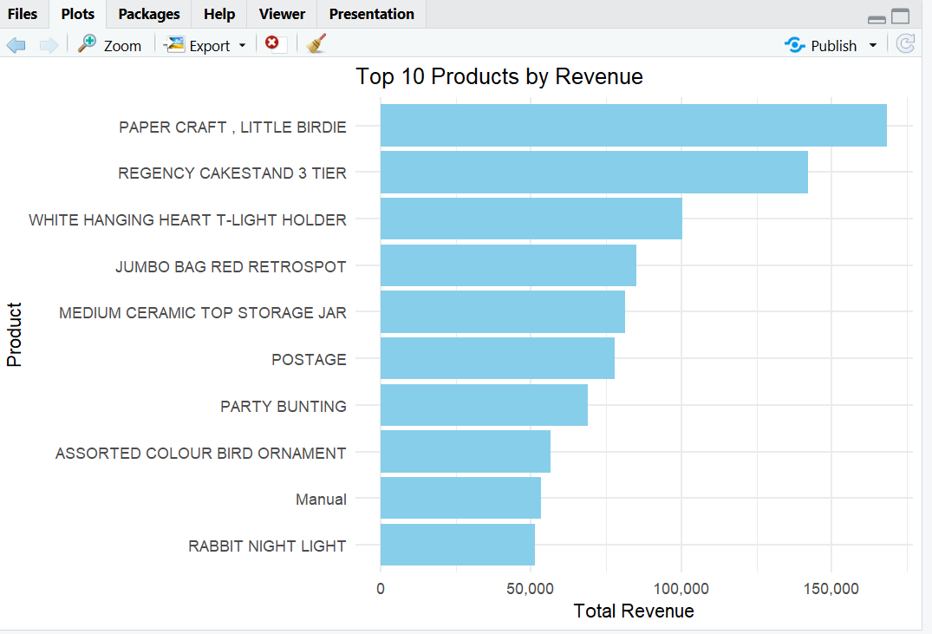

- Sales Heatmap (Weekday vs. Hour): This heatmap reveals that the peak shopping times are during midday on weekdays.

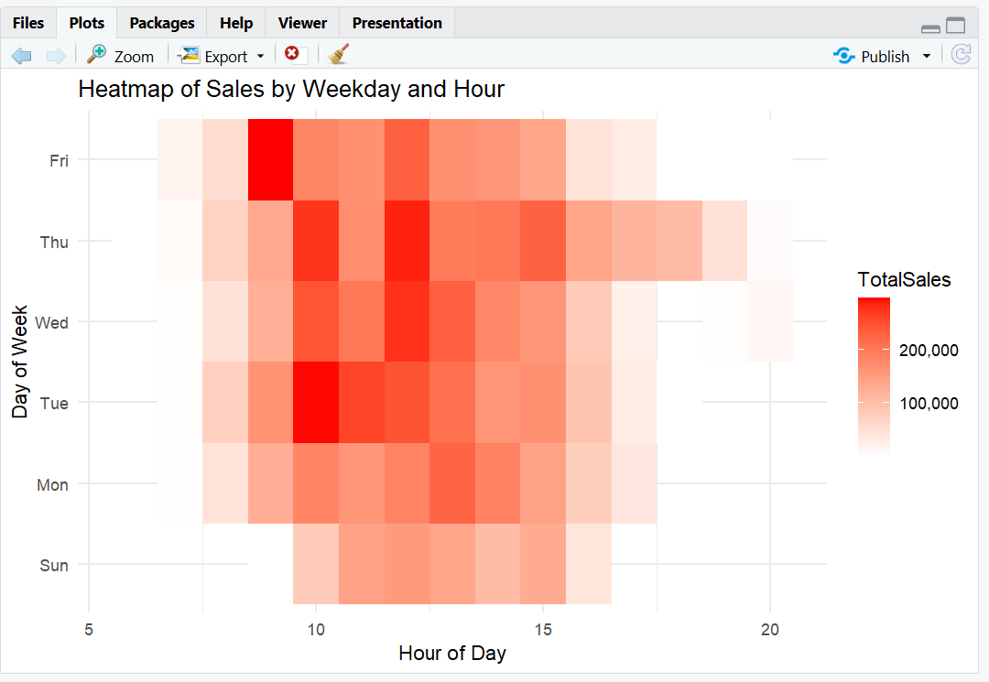

Algorithm:

Algorithm:

- Start
- Load required R libraries (tidyverse, lubridate, readxl, patchwork).
- Read dataset (Online Retail.xlsx).
- Clean data (remove NAs, duplicates, negative quantities).
- Create new variables (Revenue, YearMonth, Hour, Weekday).
- Compute monthly totals, product-level revenue, and time-based patterns.
- Generate visualizations (line, bar, heatmap).
- Combine all visuals into one dashboard image.
- Interpret results and draw conclusions.
- End.

Conclusion:
This analysis demonstrates how R can transform raw retail transaction data into clear business insights.
Key findings include:
- Sales spike during November–December, likely due to festive shopping.
- A few popular products dominate revenue, such as gift items and decorations.
- Most purchases occur mid-day on weekdays, suggesting strong office-hour buying patterns.

Recommendations:
- Increase stock and promotions before festive months.
- Focus marketing on top-performing product categories.
- Schedule system/server optimization during peak weekday hours.
Through this, the project highlights Technology-Enhanced Learning (TEL) — applying data analytics for real-world decision-making.

Dashboard: